Install for Course

Come prepared with as much of this installed as you can. We’ll also go over installs on the first day, so if you run into issues, I’ll help you.

**Download & Install Anaconda w/ Python 3**

<https://www.anaconda.com/products/individual>

* + Mac Users:

Python 3.7 Version

64-Bit Graphical Installer

* + PC Users:

Python 3.7 Version

64-Bit Graphical Installer

Follow the instructions at this [link](https://medium.com/@GalarnykMichael/install-python-on-windows-anaconda-c63c7c3d1444).

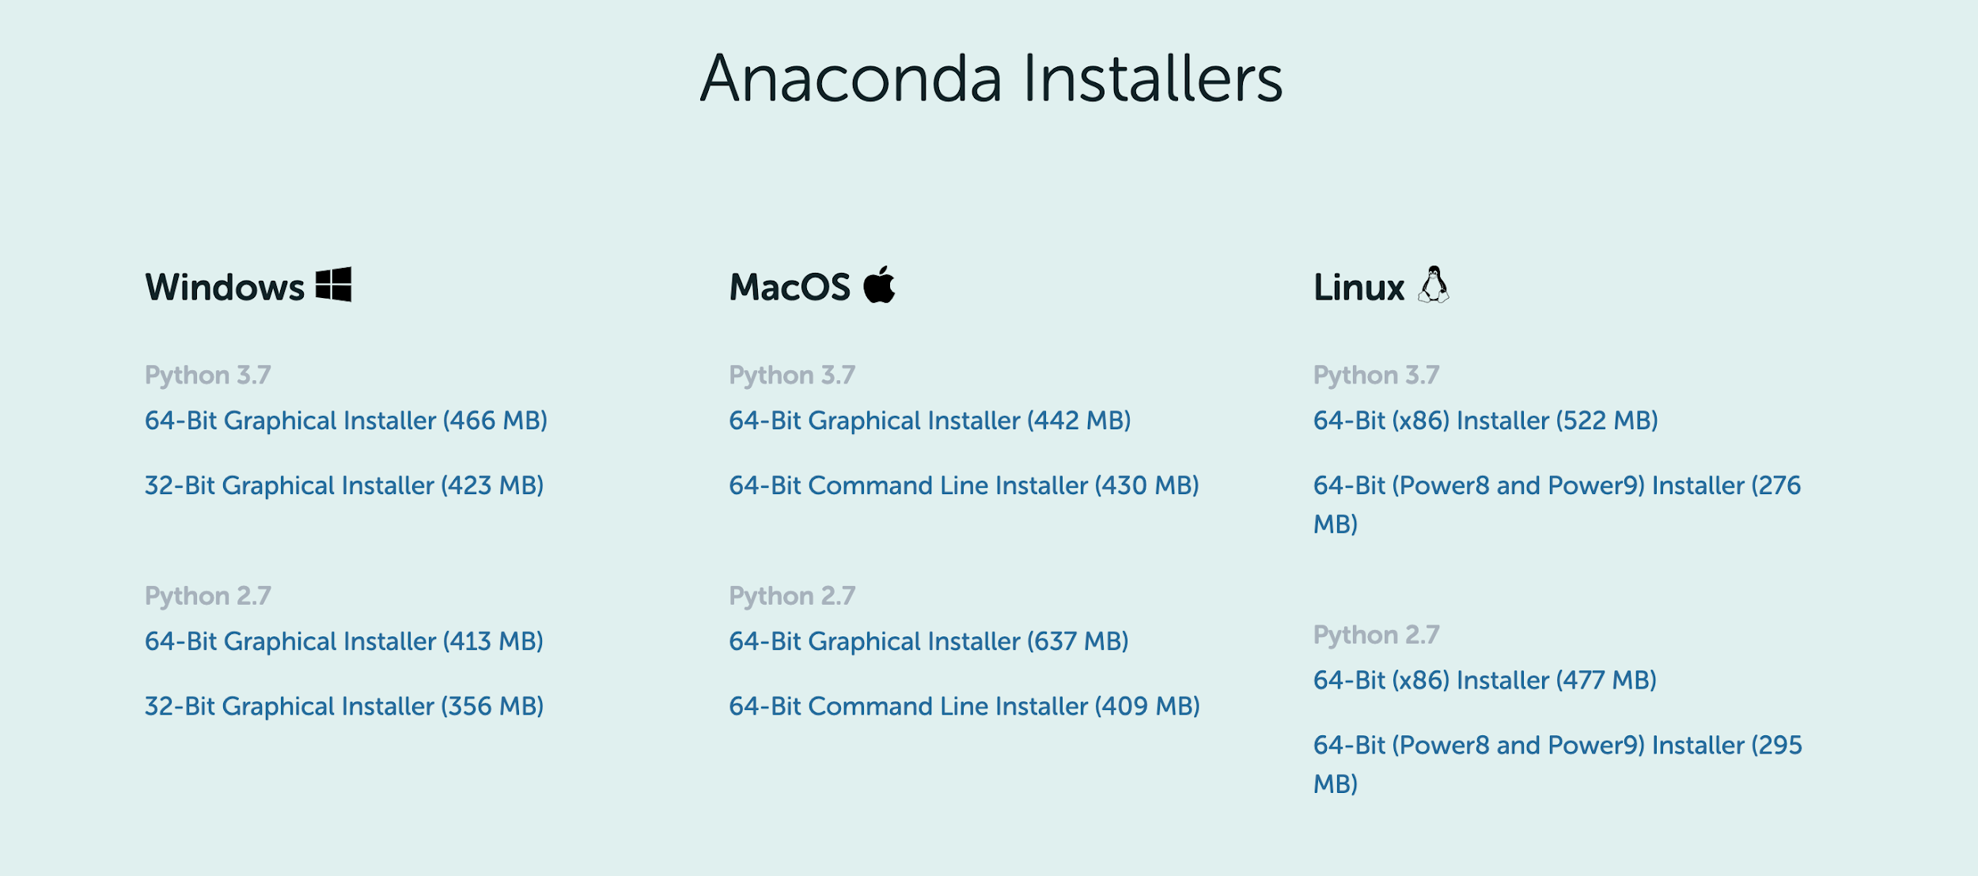

**Test your Anaconda install**

To test your installation, in your Terminal/Git Bash window or Anaconda Prompt, run the command conda list.

For a successful installation, a list of installed packages appears.